LES SURFACES ELEMENTAIRES
PLANE |  | CYLINDRIQUE |  | CONIQUE
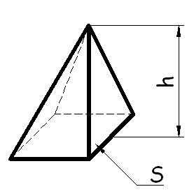 |  | 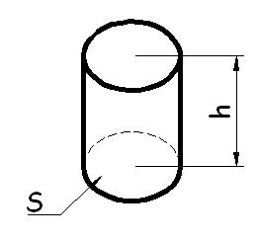 |  | 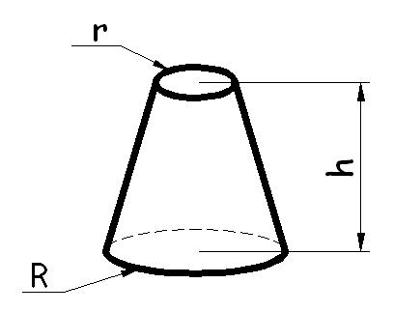

SPHERIQUE | TORE
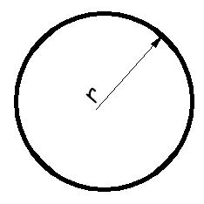 | 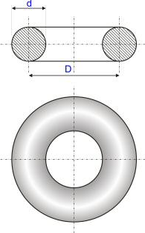

LES AIRES DES FORMES ELEMENTAIRES
CARRE |  | RECTANGLE |  | PARALLELOGRAMME
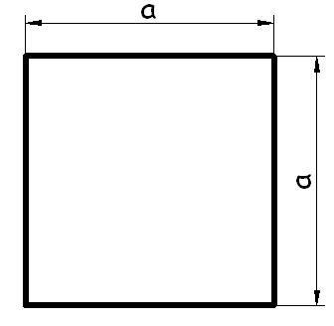 |  | 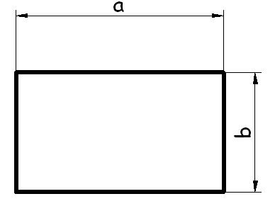 |  | 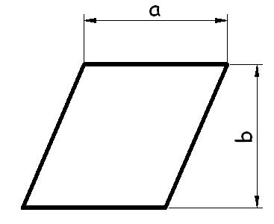
S = a² |  | S = a x b |  | S = a x b

TRAPEZE |  |  |  | TRIANGLE |  |  |  | HEXAGONE
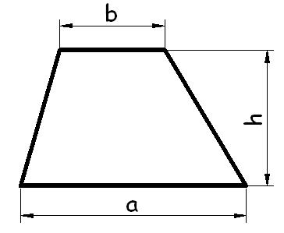 |  |  |  | 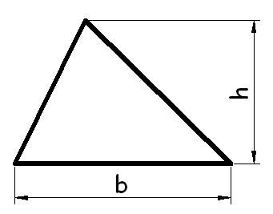 |  |  |  | 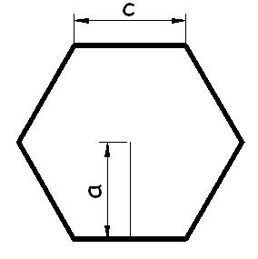
S = | a + b | X h |  | S = | b x h |  |  | S = | 6 x c | X a
 | 2 |  |  |  | 2 |  |  |  | 2

CERCLE |  |  |  | SECTEUR
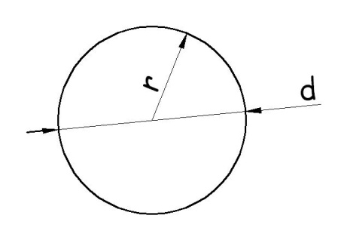 |  |  |  | 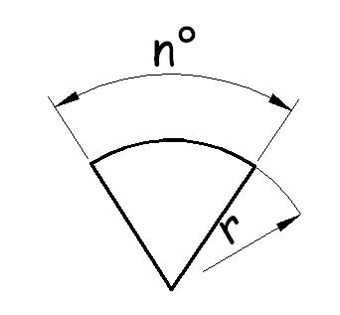
S = | π x d² | = π x r² |  | S = | π x r x n°
 | 4 |  |  |  | 360

LES VOLUMES ELEMENTAIRES
CYLINDRE |  | CUBE |  | PARALLELEPIPEDE
 |  | 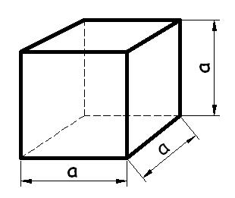 |  | 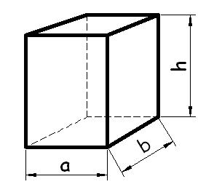
V = S x h |  | V = a³ |  | V = a x b x h

PYRAMIDE |  |  |  | PRISMES |  | SPHERE
 |  |  |  | 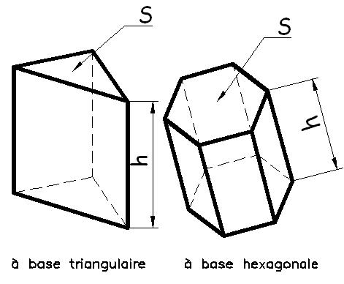
 |  |  |  | V = S x h
V = | S x h |  |  |  |  | V = | 4 x π x r²
 | 3 |  |  |  |  |  | 3

CALOTTE SPHERIQUE |  |  |  |  | TRONC DE CONE |  |  |  | CONE
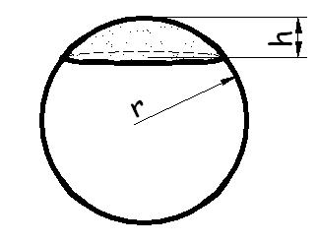 |  |  |  |  |  |  |  |  | 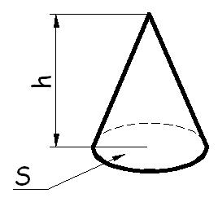
V = | π x h² x ( r - | h | ) |  | V= | π x h | ( R² + r² + ( Rxr )) |  | V = | S x h
 |  | 3 |  |  |  | 3 |  |  |  | 3

